Nazma Nurfaidah Shiyami (201344026) | Rangkuman Minggu 3 | Senin, 12 September 2022
Nazma Nurfaidah Shiyami (201344026) | Rangkuman Minggu 3 | 16TNK5043 (Aplikasi Mikrokontroler)
3-NK | Rangkuman Minggu 3 | Ferry Satria, BSEE, M.T. Rahmawati Hasanah, S.ST.,M.T.

- Konversi Data Desimal Ke Oktal
- Buat program Konversi Data Desimal 2 digit (yang ada di R20) ke Oktal. Simpan hasil konversi pada R22:R21.
- Program (Metode Penyisipan 0)
.include "m8535def.inc"
.org 0x00
rjmp main
; PAKAI PROJECT "ROOT"
main :
ldi r20,low(ramend)
out spl,r20
ldi r20,high(ramend)
out sph,r20

ldi r20,0x69 ; register input data
ldi r18,0x0a ; faktor pengali 0A
mov r16,r20
andi r16,0xf0 ; mengambil nilai puluhan
lsr r16
lsr r16
lsr r16
lsr r16
mul r16,r18 ; puluhan kali 0A
mov r16,r20
andi r16,0x0f
add r0,r16
mov r17,r0
andi r17,0x07 ;mengambil 3 LSB terkahir; awal proses penyisipan 0 pertama
mov r21,r17
mov r17,r0
andi r17,0xf8 ; mengambil 5 MSB awal
mov r25,r17
add r25,r25
add r25,r21 ; akhir proses penyisipan 0 pertama

mov r17,r25
andi r17,0x80 ; mengambil 1 MSB
mov r21,r17
mov r17,r25
andi r17,0x7f ; mengambil 7 Bit terkahir
mov r23,r17

add r21,r21
adc r22,r31
add r21,r23

akhir: rjmp akhir

- Hasil
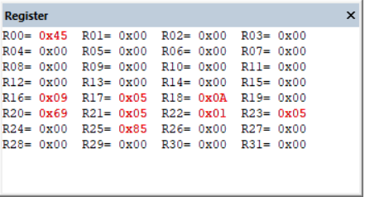

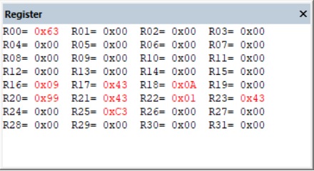

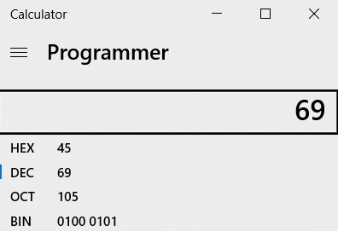
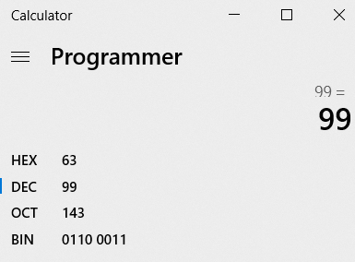
- Program (Metode Lookup Table)
.include "m8535def.inc"
.org 0x00
rjmp main

main :
ldi r16,low(ramend)
out spl,r16
ldi r17,high(ramend)
out sph,r17

ldi r18,0X60
mov r28,r20
add r28,r18
adc r29,r30
ld r21,y

akhir : rjmp akhir

- Hasil
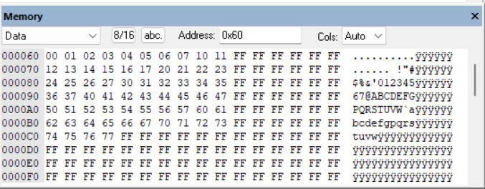
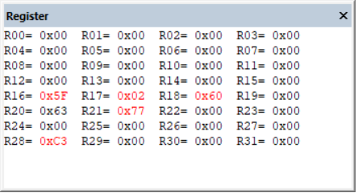

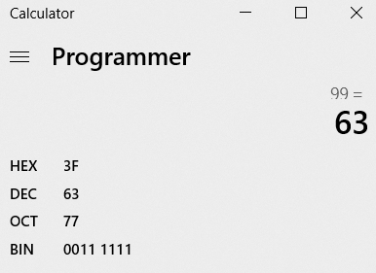

- Buat program Konversi Data Oktal 2 digit (yang ada di R20) ke Desimal. Simpan hasil konversi pada R21.
- Program
.include "m8535def.inc"
.org 0x00
rjmp main
; PAKAI PROJECT "ROOT"
main :
ldi r20,low(ramend)
out spl,r20
ldi r20,high(ramend)
out sph,r20

ldi r20,0x44 ; data input
mov r22,r20
andi r22,0xf0 ; mengambil nilai delapanan
lsr r22
lsr r22
lsr r22
lsr r22
rcall kal ; penggandaan 3 kali
mov r21,r22

mov r22,r20
andi r22,0x0f

add r21,r22
mov r19,r21
rcall daa
mov r21,r19

akhir: rjmp akhir

kal: ; subrutin perkalian 8 secara desimal = penggandaan secara 3 kali
ldi r16,0x03
l1: add r22,r22
mov r19,r22
rcall daa
mov r22,r19
dec r16
brne l1
ret

daa: push r16;amankan isi reg. ke stack
push r17
push r21
push r24
in r16,sreg; amankan sreg
in r17,sreg
ldi r24,0 ; r24 hanya sbg status dr carry flag
adc r24,r24; status carry flag sebelum koreksi
; ambil, amankan kembali sreg, uji half carry
out sreg,r17
brhc lup4; lompat ke lup4 jika H=0
rcall fk_ln; satuan + 06 jika H=1
; rjmp lup5
lup4: mov r21,r19
andi r21,$0f; ambil dgt.satuan
cpi r21,$0a ; > 9
brcs lup5; lompat ke lup5 jika < 9
rcall fk_ln; satuan + 06 jika > 9
lup5: out sreg,r17; ambil, amankan kembali sreg, uji carry
brcc lup6; lompat ke lup6 jika C=0
rcall fk_hn; puluhan + 60 jika C=1
; rjmp lup7
lup6: mov r21,r19
andi r21,0xf0; ambil dgt.puluhan
cpi r21,0xa0
brcs lup7; lompat ke lup7 jika pul < a
rcall fk_hn; pul + 60 jika > 9
lup7: out sreg,r16; mengatur carry flag sblm keluar:
clc; C = 0
in r16,sreg ;amankan sreg stlh c=0
cpi r24,0 ;menguji status
breq lup8
out sreg,r16;ambil sreg, set c
sec; C = 1
in r16,sreg; amankan sreg stlh c=1
lup8:
out sreg,r16;status akhir
pop r24;kembalikan isi reg. dr stack
pop r21
pop r17
pop r16
ret
fk_ln: ldi r21,06; koreksi dgt.satuan
out sreg,r16
add r19,r21
in r16,sreg
brcc tuh
ldi r21,0x01
add r17,r21
tuh: out sreg,r16
adc r24,r24
ret
fk_hn: ldi r21,$60; koreksi dgt.puluhan
out sreg,r16
add r19,r21
in r16,sreg
adc r24,r24; amankan carry pd r24
ret ; akhir dari prog. subrutin.

- Hasil
